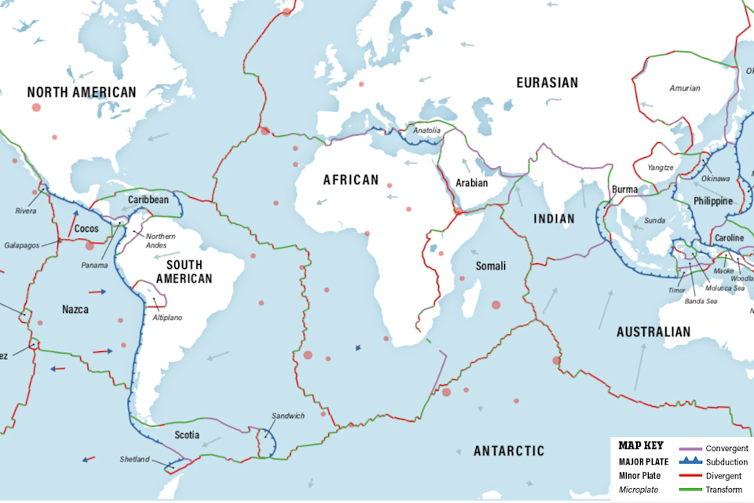

Tarlack, Gemma (2019). Plate Tectonics: The Slow Dance of Our Planet's Crust. Discovermagazine.com. https://www.discovermagazine.com/planet-earth/plate-tectonics-the-slow-dance-of-our-planets-crust

