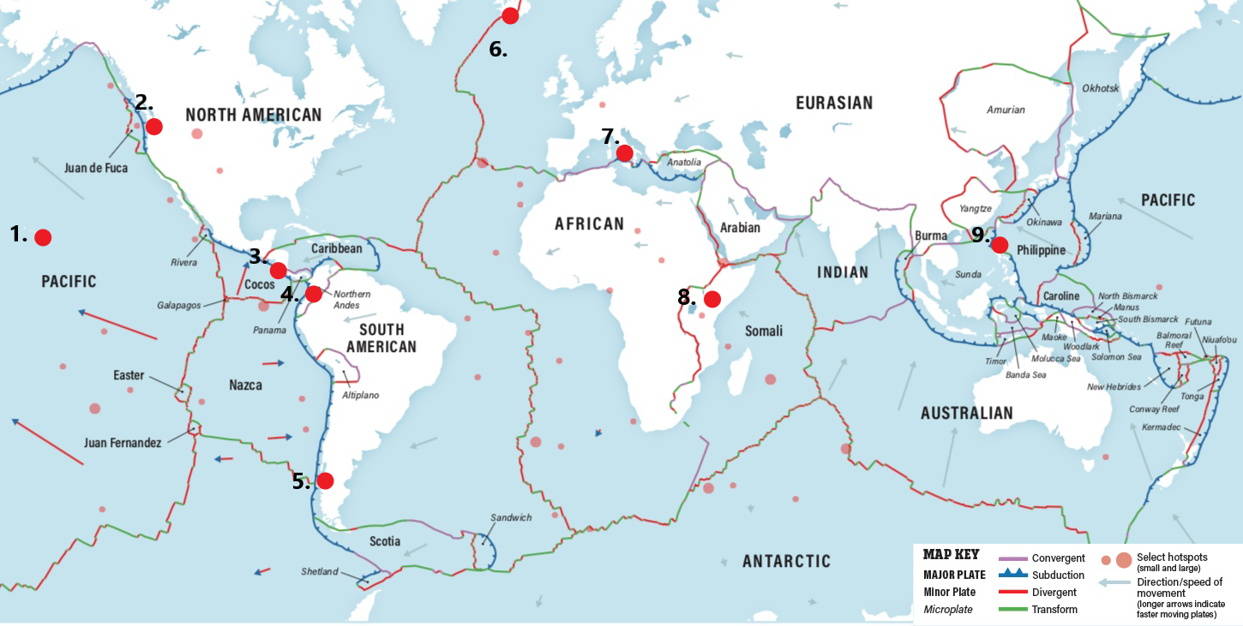

- Kilauea, Hawaii
- Mt. Saint Helen’s, Washington
- Fuego, Guatemala
- Nevado del Ruiz, Colombia
- Villarrica, Chile

- Eyjafjallajökull, Iceland
- Mt. Vesuvius, Italy
- Kilimanjaro, Tanzania
- Pinatubo, Philippines

Tarlack, Gemma (2019). Plate Tectonics: The Slow Dance of Our Planet's Crust. Discovermagazine.com. https://www.discovermagazine.com/planet-earth/plate-tectonics-the-slow-dance-of-our-planets-crust

