Fractional Crystallization
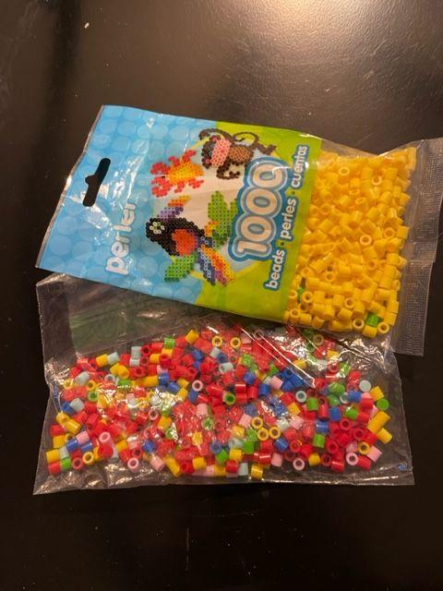
Materials:
- Bag of colored beads representing the magma chamber
- Butcher paper for marking bead progression
- Computer with Excel file
Procedure:
- Open Excel file.
- Using the “Mineral Composition” and “Minerals Crystallized” tables, determine how much of each element is removed in Step 1.
- Take the appropriate number of each element out of your “magma chamber” bag of beads and put it on the appropriate place on your butcher paper (see image below of an example of how you can set up your butcher paper).
- Count the total number of each element removed and subtract this from the initial elements in the “Elements Remaining” table. Type the results into the Step 1 column.
- Repeat #2-5 for steps 2 through 10 in your chart. In the “Elements Remaining” table, make sure to subtract from the previous step each time.
- Notice how the graphs change after each step.

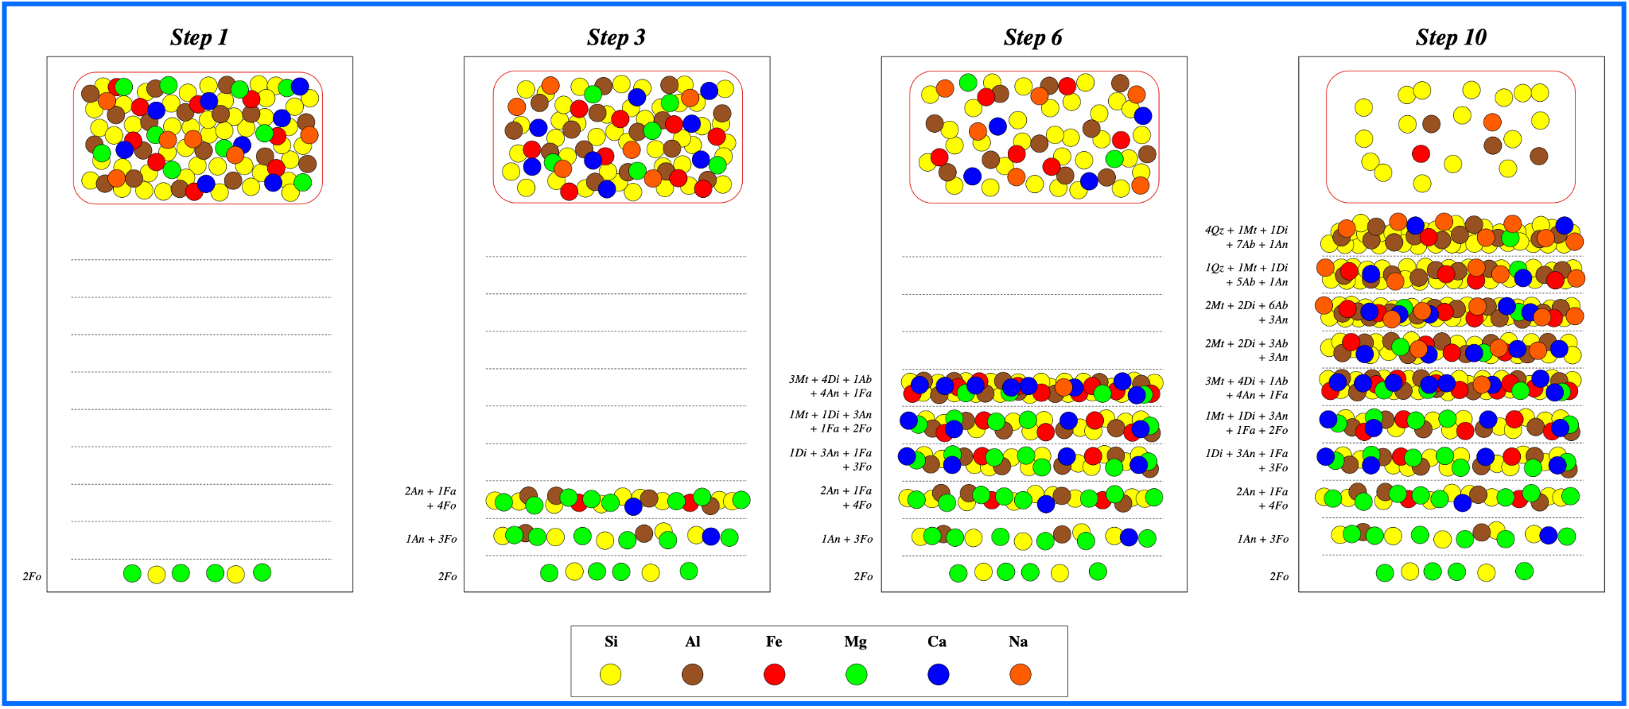
Figure 1. How to set up your butcher paper

Analysis:
- What element does each color represent?

- What were the 3 most dominant colors/elements in your magma chamber before you began taking out elements?

- What were the 3 most dominant colors/elements at the end?

- Look at the charts on the side and explain how the percentage of each element changes in the magma chamber over time (e.g., how do each of the graphs change over time?).

  - Silicon (Si)

  - Iron (Fe)

  - Aluminum (Al)

  - Magnesium (Mg)
  - Calcium (Ca)

  - Sodium (Na)

- Based on this data, did your magma chamber become more felsic or mafic as elements crystallized out (see magma compositions at the bottom of this page)?

- How would this impact the type of eruption of the volcano?

Magma Compositions
Ultramafic: mostly olivine and pyroxene, very high melting point, mantle material
Mafic: high in iron, calcium, and magnesium, less olivine, more amphibole than ultramafic, high melting point
Intermediate: high in biotite mica and potassium feldspar, medium melting point
Felsic: high in silica, potassium, and sodium, high in quartz, muscovite mica, and potassium feldspar, low melting point

